English Programmes

Considering Gender Equality in Project Design

Note: This document is intended to offer British Council external grant project partners support and guidance on how gender equality may be integrated into Overseas Development Agency (ODA) funded grant projects. For further queries or support please contact the relevant British Council project manager or contact.
This brief guide is intended to support integration on a project level, specifically for the 2022 -2023 NODE Project China, including both training and research strands, managed by English Programmes, China.
Definition of gender equality
“Gender is a social scientific term used to describe shared social ideals of femininity and masculinity, associated behavioural expectations and relations between sexes.” (BEIS, 2021, P31) We “assume gender equality to relate to people of all genders, and groups that are discriminated against, or face inequalities, based on their gender”.
Integration into projects
All British Council projects should contribute to gender equality and/or the empowerment of women and girls. The British Council supports the UN’s Sustainable Development Goals (SDGs) to achieve:
- ‘inclusive and equitable quality education for all,’ and;
- ‘gender equality and empower all women and girls’
believing that the equal inclusion of girls and boys in education systems across the world is as an important aspect of meeting the SDGs and as well as being a fundamental human right.
We also aim to meet the requirements of the Gender Equality Markers (GEM) framework.
Why we focus on gender equality in our projects
Projects that do not take account of gendered divisions in roles and experiences can lead to interventions and technologies which inadvertently fail to meet the needs of all genders, or which negatively impact on them. Furthermore, dissemination strategies, which do not take account of existing hierarchies and associated gendered asymmetries can also replicate or exacerbate existing gender inequalities in numerous areas. (BIES, 2021, P9-10)
In addition to ODA requirements, key reasons for the mandatory inclusion of gender equality considerations in our projects include:

- If relevant gender issues are missed or poorly addressed, project outputs may be potentially biased with negative impacts on gender equality.
- Excellence in project management requires a gender responsive component.
- Equal opportunities attract diverse and top-level project management and delivery staff, which improve team performance and delivery.
- A consideration of gender equality can contribute to higher quality, impactful, practical and sustainable research/innovation.
- Socially and culturally responsive projects are inclusive.
- The inclusion of formerly absent new gendered project outcomes or research questions adds novelty.
- Gender sensitivity enhances the societal relevance of the knowledge outputs, sharing and innovations, and contributes to the creation of outputs, goods and services better suited to potential beneficiaries.

Our approach
Our global approach to gender and inclusion is a holistic one, which means that we aim to tackle gender inequality from a range of different perspectives, changing systems, discriminatory norms and attitudes, and creating better access to opportunities and resources.
We work at various levels (formal, informal, individual, institutional) and with different stakeholders.
We have a twin track approach to gender quality where we are working to integrate gender across programmes, as well as developing standalone gender programmes and projects that focus on:

- Providing access to resources and opportunities
- Bring about positive change in policies that directly or indirectly impact women
- Building women’s skills confidence and agency to address gaps in capacity that have resulted from a lifecycle of disadvantage for many women across the world
- Work at in communities to change attitudes, behaviours and perceptions about gender
- Central to our approach is dialogue, collaboration and collective action – this goes to the heart of change as there needs to be action and momentum built among different groups.

Fig. 1: The British Council approach to Gender Equality

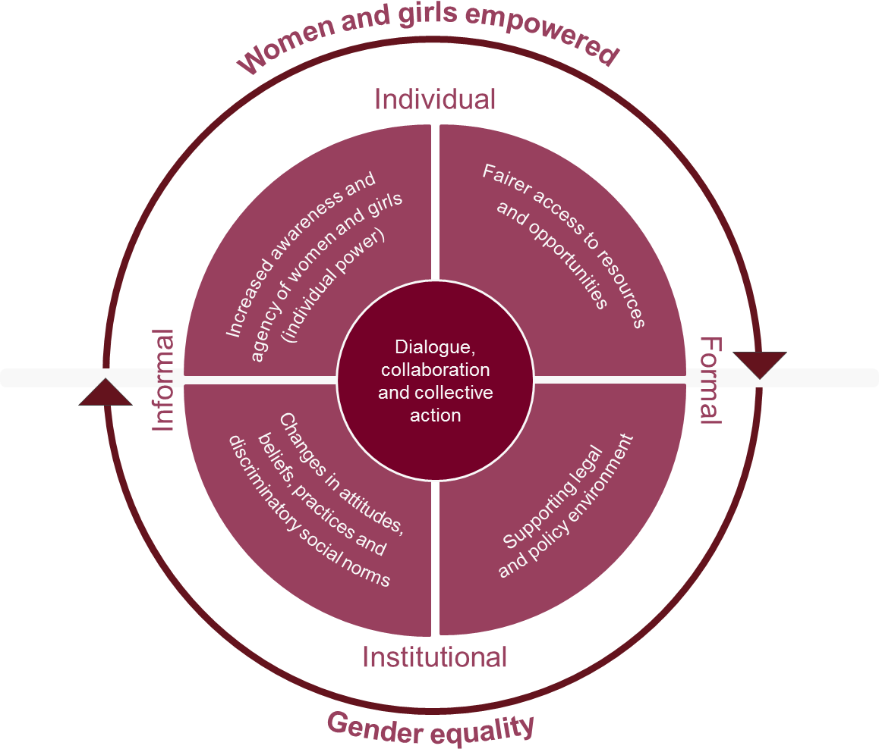

Acknowledged British Council gender criteria:

- Gender unaware (blind): programmes/projects do not recognise gender issues
- Gender neutral: programmes/projects recognise gender issues in the analysis, but not in the response
- Gender sensitive: programmes address practical gender issues (improve daily condition), but do not tackle the root causes of gender inequality
- Gender transformative: programmes improve both practical and strategic gender issues, there is an explicit intention to transform unequal gender relations (improve position of women and girls in society)

All grant funded projects provided through ODA funding must be, at a minimum, Gender Sensitive. This means that all project design, including research, must include some explicit focus or reference to areas of gender equality (GE) within their design and outcomes. In order to support projects practically integrate the considerations outlined above, a logic model and menu of possible outcomes has been constructed to help our partners scaffold and map a clear GE focus within each project model.

What should you do?
First, consider these initial questions that help us include more explicit consideration of GE at the research proposal/application stage. This will provide a strong foundation on which to build a more targeted focus:

How might I make this programme/project gender sensitive?

- Can we / Have you analysed the different needs of women and men/girls and boys in the context of the research focus? Which women/men might be affected?
- Is your project raising awareness of girls & women’s rights? Can it?
- Is your project addressing the practical needs of women and girls? Can it?
- Is your project contributing to raising the profile of the roles of English teacher in the China context? Can it?
- Are you collecting sex-disaggregated data?

Please bear in mind that in some contexts, women dominate the teaching profession and thus there is a perception that because the majority of project stakeholders are female, the project doesn’t need to pay attention to women’s empowerment and gender equality. Simply because
we are investing in training female teachers, or the project will involve a significant number of female teachers, does not make a project gender sensitive or transformative. Unpacking some of the drivers behind the predominance of women in teaching is important e.g., the social status of the role, the perception of the role amongst different stakeholders and genders, the conditions applied to the role such as earning potential, prospects etc. Teaching, and English teaching in particular, may be perceived as an extension of the stereotypical view of women being mothers and nurturers, particularly with regard to teaching at primary level. This is often reflected in how the role of English teacher is perceived and its status within the local community; and also amongst peers in other disciplines. It is notable that we often see fewer female teachers at higher levels of education in (perceived) more prestigious fields of study and in leadership positions. In secondary schools, women are also less frequently found teaching science, mathematics and technology classes, but conversely predominate language classes in many contexts. (British Council, 2022)

On average across OECD (2017) countries, 68% of lower secondary teachers are women, but only 45% are principals - this is particularly striking given that principals tend to be recruited from

among the ranks of teachers – suggesting that female teachers are less likely to be promoted to principal than their male counterparts. So, the large share of women in the teaching profession more generally is, on appearance, skewed towards specific jobs: those at the bottom of the education pyramid and the bottom of the hierarchy of power. This may be even more prevalent within English teaching contexts.

Addressing these considerations, British Council English Programmes have formulated a key overarching gender equality objective for English Programmes in East Asia (2021 -2025) with specific focus on the role of the English teacher. This is:

To raise the profile and status of English teachers at institutional and provincial levels and help ensure they are adequately recognised for their role in formal education, and that ultimately the role of the English teacher becomes more attractive, socially and financially, for quality candidates from different genders.
This objective applies to both male and female teachers of English, and provides a clear target towards which any GE consideration within a project and/or related research can work towards. Many of the outcomes listed in the logic model specifically contribute to this objective.

Considering the logic model ‘menu’ as framework of guidance
Next, after some reflection on how gender may be incorporated into the project design, the logic model and provided outcomes should be reviewed to help frame any enquiry or focus that can be included within the expected project scope or findings, or that may emerge from the Project activities. The suggested outcomes offer areas of focus that act as signposts for integration of gender equality considerations into each project, and allow the project to effectively target areas that can contribute towards larger, higher level aims or aspirations.
However, importantly, there also remains flexibility within this framework for UK partners to develop a specific contextualised focus, should the suggested option not be appropriate. Or, indeed, to adapt those that are presented for more specific focus on a certain area. This is intended as a guide only.
The logic model framework is intended to act as a menu of potential foci that offers short-term outcomes and considerations to be included directly in your project. The final outcomes are chosen by the project designer. Based on the methods and content of selected project and/or research tools, I.e., activity organisation, questions asked, and areas focused on, short-term gender equality-focused outcomes can be mapped to mid to long - term outcomes that contribute more widely, spotlighting and providing clarity on the longer-term implications and benefits of specific research.
Initial mapping of these outcomes provided should be justified in grant applications. Therefore, first consider:

- Which specific, achievable short-term GE outcomes might I select for my project? (See below)
- Can I define these further within the context of the project? (Note: You can adapt outcomes provided, with justification, where there are clear, specific outcomes that can be contextually designed and applied.)
- Will my focus only be on the context of women/girls? Will men and boys also form part of this?
- How might the short-term outcomes map or build towards future contributions in GE (I.e., mid to long-term outcomes)?
- How will I make sure this happens in the project? (I.e., through tools, methodologies, team)
- How can I record the results and insight gained towards my selected outcomes within the scope of the project reporting?

Please ensure that relevant outcomes from the model listed below (or your adaptations of these) are included within the project design (and application), and where applicable referenced in project reports. As many of the short-term outcomes as possible, if not all, should be included within the initial and final project design, particularly where research is included. Specific consideration should be paid to #5 and #6.
Please also note that there may also be cross-project opportunities to combine similar findings for maximum impact, and this could be explored with support of the British Council team once the project design has been finalised to maximise potential impact.

References:
Department of Business, Energy & Industrial Strategy (BEIS) (2021) Gender Equality in Research and Innovation Official Development Assistance (ODA), OGL, Crown Copyright.
OECD (2017) Education and Skills Today - https://oecdedutoday.com/why-do-so-many-women-want-to-become-teachers/
British Council internal policy document (2022) English for Education Systems (EES): integrating Women’s Empowerment and Gender Equality into projects or programmes
To achieve GEM (Gender Equality Marker) 1. Gender equality is an important and deliberate objective, but not the principal reason for undertaking the project. The gender equality objective must be explicit in the project documentation and cannot be implicit or assumed.
Target groups: English language teachers and, more widely, decision makers and thought leaders in public education systems in China.
English Programmes Gender Equality East Asia Programme Objective (1-4 years): To raise the profile and status of English teachers at institutional and provincial levels and help ensure they are adequately recognised for their role in formal education, and that ultimately the role of the English teacher becomes more attractive, socially and financially, for quality candidates from different genders.
 | What we must strive for in the project… | What we hope our work (and this project) will contribute to over the longer term …. | Building towards…
Project | Short Term GE Outcomes/Outputs (E.g., < 1 year) | Mid-term GE Outcomes/Outputs  (E.g., 1 – 4 years) | Longer term GE outcome
NODE Project | - Participating project teams have been gender-balanced and representative.  - Participating project teams have demonstrable expertise on gender equality & EDI.  - Local gender equality considerations (barriers and opportunities) related to both men and women have been analysed and included within the project.  - Recruitment for all activities has been inclusive, balanced and representative to ensure, in particular, maximised participation of female teachers in rural and under-developed areas. E.g. consideration of language used, distribution methods, and timeframes for completion.  - Project activities have ensured as even a participatory gender balance as possible and clearly disaggregated data; working towards a balance of 50-50 where feasible.  - Project activities and tools have been created ‘gender-sensitive’ and have identified and considered specific indicators and questions related to local, practical gender equality issues within its tools that can lead to actionable insight. | - The project activities or research will have contributed to the better understanding of reasons for (lack of) participation of women in a) research activities b) English Language Teaching in China c) related CPD activities.  - The project activities or research will contribute to a better understanding of the status and attractiveness of the role of English teacher as a career proposition for both men and women.  - The project activities or research will have contributed more generally to identifying and resolving any common disparities between men and women in ELT within China.  - The project activities or research will have raised local awareness of gender equality related issues and challenges amongst leaders and practitioners in ELT in local public education systems.  - The project activities or research will have empowered female teachers and key stakeholders to address existing inequalities or barriers.  - Specific solutions identified will have been acted on or followed up on by decision makers within the local context.  - The project activities or research will have contributed to increased skills, awareness and agency for both male and female teachers, as per identified need.  - The project activities or research will have contributed to fairer access to resources and opportunities for both male and female teachers, as per identified need.  - The project activities or research will have contributed to a more supportive legal & policy environment in areas of Gender Equality.  - The project activities or research will have contributed to changes in attitudes, beliefs, practices and discriminatory social norms.  - The project activities or research will have contributed to constructive dialogue, collaboration and collective action in areas of Gender Equality.  - The project activities or research will have contributed to empowering women in ELT in public education systems through raising awareness of specific, related issues in the local context. | We will make a significant contribution to global gender equality and the empowerment of women and girls
Project Outputs require…
- Project reports/relevant outputs should have identified any issues, and where possible offered solutions or recommendations, that address issues of gender equality in the project context within a specific area of the report, or separate document.

Note: All project and research reports, should have an explicit section based on gender equality considerations. The format of this section may differ based on output, and should be agreed with the British Council project team as the primary funder. The outcomes above are intended to act as a guide within which gender equality considerations can be framed in reporting. This may also guide evidence collection methods and content, if established early in the process.

Most projects that are not standalone gender equality focused must meet the ‘gender sensitive’ criteria
This question is aligned with a British Council English Programmes East Asia regional goal of raising the status of English teachers, and supports equality in enhancing and positively impacting on how the role is perceived.

